**Name: Ashish Mukherjee**

**Class: LY CSE NS –‘A’**

**Roll No: 2193060**

**Subject: NML**

**Assignment 9**

**Objective**: Explain TMN Operations System Functions with TMN standards.

## Theory:



Data Communication Network

Telecommunication network

Work Station

Exchange

systems

Exchange

systems

Exchange

System

System

Operations System

The term TMN is introduced by the ITU-T (the former CCITT) as an abbreviation for

`Telecommunications Management Network'. The concept of a TMN is defined by Recommendation M.3010 . TMN has a strong relationship with OSI management , and defines a number of concepts that have relevance for Internet Management .

“TMN is conceptually a separate network that interfaces a telecommunications network at several different points". ITU-T Recommendation defines TMN as a conceptually separate network that interfaces with one or more individual telecommunications networks at several points in order to send or receive information to or from them and control their operation.

The relationship between a TMN and the telecommunication network that is managed, is shown in Figure 1. According to this figure, the interface points between the TMN and the telecommunication network are formed by Switching Exchanges and Transmission systems . For the purpose of management, these Switching Exchanges and Transmission systems are connected via a Data Communication Network to one or more Operations Systems. The switching systems contain both analog and digital switches. Hence the transmission systems are both analog and digital and include all transport facility modes, including twisted pair, coaxial, fiber optics, and wireless. The Operations Systems perform most of the management functions; these functions may be carried out by human operators but also automatically. It is possible that a single management function will be performed by multiple Operations Systems. In this case, the Data Communication Network is used to exchange management information between the Operation Systems. The data communication network components consist of LANs, bridges, routers, gateways, and hosts. The Data Communication Network is also used to connect Work Stations , which allow operators to interpret management information. Work Stations have man-machine interfaces, the definition of such interfaces fall outside the scope of TMN (Work Stations are therefore drawn at the border of the TMN).

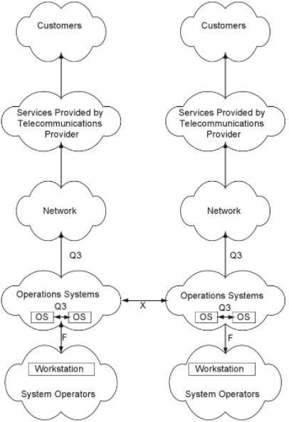

The two columns in the figure show the identical components of two service providers, A and B. These components are workstations, OSs, networks, services, interfaces, operators of the systems, and customers who use the services. Customers buy services from service providers, and providing quality customer services should be a key part of a service provider's business. Thus service management is an important consideration in the TMN model. The service provider sells telecommunication services to customers, which means that the telecommunications network needs to be operated efficiently and economically. The OAM&P of a network needs to be automated as much as possible to decrease both response time and costs. Cost considerations lead to business management, which also is addressed by the TMN model. Service management, business management, and network management can all be accomplished, partially or totally, by using the OSs shown in Figure.

# Operations System Functions

The Operations System Functions (OSF) block initiates management operations and receives notifications. In terms of the manager-agent model, the OSF may be seen as the manager spe- cific functions. An OSF communicates with the NEF over a q3 reference point (Figure 7).

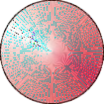

OSF

q3

NEF

*Figure 7: OSF and NEF*

The initial 1988 version of M.30 defined three different q reference points: q1, q2 and q3. The q3

reference point is used whenever management information should be exchanged via an application layer management protocol, such as the Common Management Information Proto- col (CMIP [6]) of OSI. The two other reference points were intended for cases in which man- agement information should be exchanged via lower layer (e.g. data link) management proto- cols. After some time it appeared however that it was impossible to make a distinction between q1 and q2; these two reference points were therefore replaced by the generic qx reference point.

Figure 8 shows the relation between OSF, NEF and q3, expressed in terms of the OSI service and protocol concepts. The service provided at the q3 reference point is generally the *Common Management Information Service* (CMIS [5]).

|  |  |  |
| --- | --- | --- |
| OSF  (manager) |  | NEF  (agent) |
| q3 reference point | | |

*Figure 8: Relation between OSF, NEF and q3, expressed in terms of OSI concepts*

Within a single TMN (operated by a single administration) multiple OSFs may be defined. If necessary, these OSFs can communicate with each other over q3 reference points. It is also possible that OSFs in different TMNs (operated by different administrations) communicate with each other; in this case communication takes place over a *x* reference points.

# TMN standardization

The TMN standardization started in 1985 by CCITT Study Group IV [1]. The first TMN recom- mendation was called M.30 [2] and was published in 1988 as part of the *blue books*. In 1992 a completely revised version appeared and the number of the recommendation was changed into M.3010. This version changed again in 1996 [4].

As compared to the 1988 version of M.30, the 1992 version of M.3010 removed the sections on ‘Planning and Design’ (which became an appendix) and on ‘Functions associated with TMN’. The 1992 version added also a number of new sections, such as those on the ‘TMN Information Architecture’. The most important changes of the 1996 version relate to ‘TMN’s Logical Layered Architecture’.

Since 1988 a number of related recommendations have been defined. These recommenda- tions refine specific aspects of TMN and use M.3010 as the architectural basis (see Figure 2). In addition, a large number of TMN recommendations were defined for ISDN management.

Overview of

TMN Recommendations M.3000

Principles for a TMN

M.3010

Terms and definitions TMN

M.60 §2

Management service 1*

X interface: M.3320

Management service n*

TMN management functions M.3400

Catalogue of TMN management information M.3180

TMN management capabilities at the

F interface: M.3300

TMN management services: overview M.3200

Generic network information model for TMN

M.3100

TMN interface specification methodology M.3020

*Figure 2: Relation between TMN recommendations*

**Conclusion:** TMN Operations System Functions with TMN standard explained